**Hand Gesture Controlled Vehicle**

Submitted in partial fulfillment of the requirements

of the degree of

Bachelor of Engineering

in

Information Technology

by

|  |  |
| --- | --- |
| Vikrant Deshmukh | 218A3066 |
| Digamber Mulik | 218A3069 |
| Mehul Patil | 218A3071 |

Under the Guidance of:

Prof. Stuti Ahuja



Department of Information Technology

SIES graduate School of Technology

2020-21

**CERTIFICATE**

This is to certify that the IoT Mini project entitled **“Hand Gesture Controlled Robot Vehicle”** is a bonafide work of the following students, submitted to the University of Mumbai in partial fulfillment of the requirement for the award of the degree of **Bachelor of Engineering** in **Information Technology.**

|  |  |
| --- | --- |
| **Vikrant Deshmukh** | **218A3066** |
| **Digamber Mulik** | **218A3069** |
| **Mehul Patil** | **218A3071** |

Prof.Stuti Ahuja Dr. Lakshmi Sudha Dr. Atul N Kemkar

Internal Guide Head of Department I/C Principal

**PROJECT REPORT APPROVAL**

This IoT Mini project report entitled ***Hand Gesture Controlled Robot Vehicle*** by following students is approved for the degree of ***Bachelor of Engineering*** in ***Information Technology.***

|  |  |
| --- | --- |
| ***Vikrant Deshmukh*** | ***218A3066*** |
| ***Digamber Mulik*** | ***218A3069*** |
| ***Mehul Patil*** | ***218A3071*** |

**Name of External Examiner: --------------------------------**

**Signature: --------------------------------**

**Name of Internal Examiner: --------------------------------**

**Signature: --------------------------------**

**Date:**

**Place:**

**DECLARATION**

I declare that this written submission represents my ideas in my own words and where others’ ideas or words have been included, I have adequately cited and referenced the original sources. I also declare that I have adhered to all principles of academic honesty and integrity and have not misrepresented or fabricated or falsified any idea/data/fact/source in my submission. I understand that any violation of the above will be cause for disciplinary action by the Institute and can also evoke penal action from the sources which have thus not been properly cited or from whom proper permission has not been taken when needed.

|  |  |  |
| --- | --- | --- |
| Vikrant Deshmukh | 218A3066 | ______________ |
| Digamber Mulik | 218A3069 | ______________ |
| Mehul Patil | 218A3071 | ______________ |

Signature

Date:

**ACKNOWLEDGEMENT**

It gives us immense pleasure to thank Dr. Atul N Kemkar, our I/C Principal and HOD EXTC for extending his support to carry out this project and also providing us the target boards to work and develop the project. We also thank to our Head of Department Dr. Lakshmi Sudha for her support in completing the project. We wish to express our deep sense of gratitude and thank to our Internal Guide, Ms. Leena V Ladge for her guidance, help and useful suggestions, which helped in completing our project work in time. We are thankful to our Department Project coordinator Ms. Savita Lohiya, for her guidance provided whenever required.

Also, we would like to thank the entire faculty of Information Technology Department for their valuable ideas and timely assistance in this project, last but not the least, we would like to thank our non-teaching staff members of our college for their support, in facilitating timely completion of this project.

**Project Team**

Vikrant Deshmukh

Digamber Mulik

Mehul Patil

**ABSTRACT**

In this Project we are going to develop s a Hand Gesture Controlled Robot using Arduino, which can be controlled by simple hand gesture. According to the movement of the person hand, the accelerometer start moves. It is based on 3axis of accelerometer and robot move in four direction forward, backward, left and right. For sensing Human motion, we use infrared sensor, its range is 790nm wavelength from human body.

This type of robot widely used in military application, industrial robotic, construction field. In such a field, it is very risky and complicated to handle the machines through switches or remote, sometimes operator may be confused so this new concept introduces to control the machine with the movement of hand which will simultaneously control the robot.

The model projected is controlled through a motion device that is mounted on the hand gloves. This style helps physically challenged folks and additionally for sure tasks educated by human. the most aim of this style is to manage the automaton victimization hand gesture. measuring device utilized in the planning senses the direction of hand movement and sends an indication to Arduino Nano. Four main Hand gesture movements like FORWORD, BACKWORD, LEFT and RIGHT area unit detected and enforced.

In this system, a gesture driven robotic vehicle is developed, in which how the vehicle is moving i.e., control and handling is depend on user gesture. This type of control is mostly used in virtual world compute games. This control make switching system is more real and give more freedom to user.

**Contents**

|  |  |  |
| --- | --- | --- |
|  |  | **Page No.** |
| **Chapter 1** | **Introduction** | **9** |
| **Chapter 2** | **Hand Gesture Techniques** | **10-11** |
| **Chapter 3** | **Review of Literature** | **12** |
| **Chapter 4** | **Study of various target boards** | **13-15** |
| **Chapter 5** | **Report on Proposed system and its implementation** | **16-18** |
| **Chapter 6** | **Code** | **18-21** |
| **Chapter 7** | **Test and Procedures** | **22** |
| **Chapter 8** | **Final Result** | **23** |
| **Chapter 9** | **Conclusions** | **24** |
|  | **8.1 Future Scope** | **24** |
| **References** |  | **25** |

**List of Figures**

|  |  |  |
| --- | --- | --- |
| **Figure**  **No.** | **Figure Caption** | **Page**  **No.** |
| 4.1 | Receiver Station | 15 |
| 5.1 | Transmitter Block Diagram | 16 |
| 5.2 | Receiver Block Diagram | 17 |
| 5.3 | Circuit diagram of Receiver Section | 18 |
| 5.4 | Circuit Diagram of Transmitter Section | 18 |
| 8.1 | Robot Vehicle | 23 |
| 8.2 | Hand Gesture Controller | 23 |

**CHAPTER 1**

**INTRODUCTION**

Robotics is the system which deals with construction, design and operation. This system is related to robot and their design, manufacturer, application. Robotics research today is focused on developing systems that modularity, flexibility, redundancy, fault- tolerance and some other researchers are on completely automating a manufacturing process or a task, by providing sensor based to the robot arm. In this highly developing industry and man power are critical constraints for completion of task. To save human efforts the automation playing important role in system. This system is useful for regular and frequently carried works. One of the major and most commonly performed works is picking and placing of jobs from source to destination.

In the earlier system, the motion of the human hand is sensed by the robot through sensors and it follow the same. As the person moves their hand, the accelerometer also start moving accordingly motion of the hand sensor displaces and this sensor senses object or parameter according to motion of hand.

In this system, a gesture driven robotic vehicle is developed, in which how the vehicle is moving i.e., control and handling is depend on user gesture. This type of control is mostly used in virtual world compute games. This control make switching system is more real and give more freedom to user.

**CHAPTER 2**

**HAND GESTURE TECHNIQUES**

For a wide range of applications dynamic, non-contact hand gestures are used. From a selective literature review the following applications have been found: remote crane control; aircraft traffic control; human computer Interaction; virtual environments; remote robot manipulation; wearable human computer interfaces home appliance control TV control music; room lighting hearing aids weather forecasting presentations mobile phone translation jukebox and 3D Kiosk .The two common factors in all of the above applications are the use of dynamic and non-contact hand gestures.

**A. Contact and Non-Contact Hand Gestures**

It is recognized that contact-based hand gestures using a touch pad and expansion of existing handwriting recognition techniques is a possible gesture-based interface for in-vehicle secondary controls which are providing safety benefits. The contact-based hand gestures allow a more in-depth analysis of non-contact gesture recognition technologies and possible automotive applications. The three different factors are offers by non-contact gesture recognition. firstly, no working in-vehicle non-contact dynamic hand gesture-based system could be found maximum research efforts. Secondly, non-contact gestures meant there was no physical interface at all, and thirdly, dynamic noncontact gestures could possibly be used outside the vehicle, although this does not offer any safety benefits, it does offer the opportunity for further experimentation with new ideas and concepts.

**B. Dynamic and Static Hand Gestures**

According to the research, it was understood that for replace existing secondary controls by using static hand gestures, the driver would have to recall potentially hundreds of individual hand gestures each of which would map to a particular in-vehicle secondary control. This static hand gestures create too many problems because drivers are unlikely to work all these gestures and if they did the additional mental workload that providing safety benefit. Finally, use of dynamic hand gestures appears to be much clearer than static gestures with less ambiguity, only when observing human-to-human communications are present. For these basic common-sense reasons, to concentrate on researching dynamic hand gestures only was initially decided.

**C. Gesture Driver Interaction**

When reviewing previous research, it is interesting and instructive that when gestures are used the differences in different approach with driver interaction is present. In particular visual reminders, gesture location and system feedback, these are now briefly described.

**D. Gesture Location**

It is possible to perform a hand gesture practically anywhere within the drivers reach zone, there are three zones like dynamic, non- contact hand gestures can be performed for in-vehicle controls.

If a specific gesture zone is not to be used and gestures are to be used as a supplementary input method, then it could be argued there is a fourth potential location, namely at or adjacent to the relevant tactile control, this may help users with mental modeling of the gesture and aid recall.

No research has been identified on the best location of hand gestures that would provide maximum safety for in-vehicle applications, ease of use and user acceptability.

**CHAPTER 3**

**REVIEW OF LITERATURE**

Using Teach box for Programming and control of a robot is a tiresome and time-consuming task that requires technical knowledge. Therefore, the approach is to have new and more intuitive ways for programming & control of robot. In the robotics field, several research efforts have been made to create user-friendly teach pendants, implementing user interfaces such as color touch screens, a 3D joystick. But these techniques are not efficient to control the robot as they do not give accurate results and provide slow response time. In the past years the manufacturers of robot have made efforts for creating “Human Machine Interfacing Device” Using gesture recognition concept, it is possible to move a robot accordingly.

Accelerometers are the main technologies used for human machine interaction which offer very reasonable motion sensitivity in different applications. Motion technology makes easy for humans to interact with machines naturally without any interventions caused by the drawbacks of mechanical devices. Accelerometer-based gesture recognition has become increasingly popular over the last decade compared to vision-based technique.

The factors that make it an effective tool to detect and recognize the human gestures are its low-moderate cost & relatively small size of the accelerometers.

**CHAPTER 4**

**STUDY OF VARIOUS TARGET BOARDS**

**Arduino Nano: -** The Arduino Nano is a small, complete, and breadboard-friendly board based on the ATmega328 (Arduino Nano 3.0) or ATmega168 (Arduino Nano 2.x). It has more or less the same functionality of the Arduino Duemilanove, but in a different package. It lacks only a DC power jack and works with a Mini-B USB cable instead of a standard one. The Nano was designed and is being produced by Gravitech.

Following are the Specifications of Arduino Board:

|  |  |
| --- | --- |
| 1. Microcontroller | Atmel ATmega168 or ATmega328 |
| 1. Operating Voltage (logic level) | 5V |
| 1. Input Voltage (recommended) | 7-12 V |
| 1. Input Voltage (limits) | 7-12 V |
| 1. Digital I/O Pins | 14 (of which 6 provide PWM output) |
| 1. Analog Input Pins | 8 |
| 1. 40 mA | 40 mA |
| 1. Flash Memory | 16 KB (ATmega168) or 32 KB (ATmega328) of which 2 KB used by bootloader |
| 1. SRAM | 1 KB (ATmega168) or 2 KB (ATmega328) |
| 1. EEPROM | 512 bytes (ATmega168) or 1 KB (ATmega328) |
| 1. Clock Speed | 16 MHz |
| 1. Dimensions | 0.73" x 1.70" |

**Programming: -** Arduino uses Arduino IDE to compile and upload its programs. Arduino uses C/C++ programming language to perform its functions on board. All standard C/C++ functions works on Arduino.

1. First, setup the port and connector of the board.
2. In Arduino IDE, there are three parts of programming: -

* Initialization
* Void setup()
* Void loop()

1. The, void setup() function is used to declare the port number used on board.
2. The, void loop() function is where the actions of the code is written.
3. Now, compile the program and upload in Arduino board.

**Interfacing of Sensors: -**

**MPU6050**

The MPU6050 is one of the most commonly used Sensor Modules by hobbyists and enthusiasts. It consists of Accelerometer and Gyroscope on the same IC and provides 6 Degrees of Freedom (3-axis of Accelerometer and 3-axis of Gyroscope).

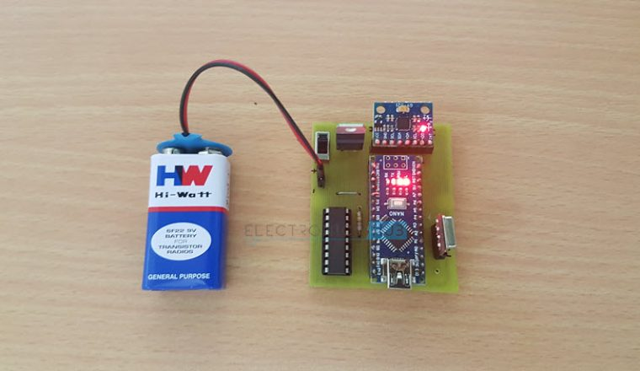

**Fig 4.1**

**RF Transmitter and Receiver Modules**

The communication between transmitter and receiver is using RF modules. A 434 MHz transmitter and receiver pair are used in this project.

**HT-12E**

It is an encoder IC that converts the 4-bit parallel data into serial data in order to transmit over RF link.

**HT-12D**

It is a decoder IC that converts the serial data received by the RF Receiver into 4-bit parallel data. This parallel data can be used to drive the motors.

**OV7670**

* Image Sensor Array(of about 656 x 488 pixels)
* Timing Generator
* Analog Signal Processor
* A/D Converters
* Test Pattern Generator
* Digital Signal Processor(DSP)

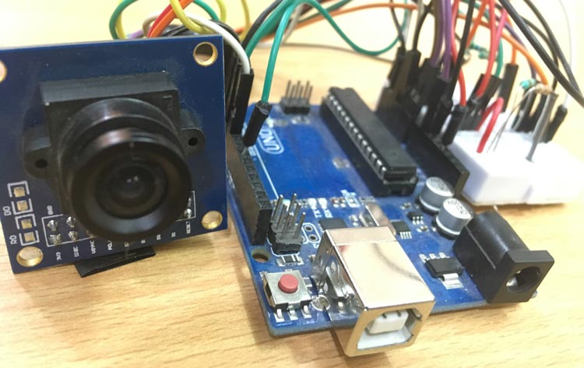

**CHAPTER 5**

**REPORT ON PROPOSED SYSTEM AND ITS IMPLEMENTATION**

As per our system, below is the required Block diagram along with circuit diagram.

**Transmitter Block Diagram**

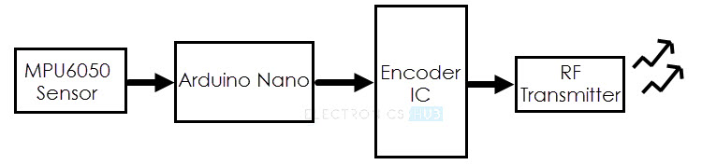

**Fig 5.1**

**Receiver Block Diagram**

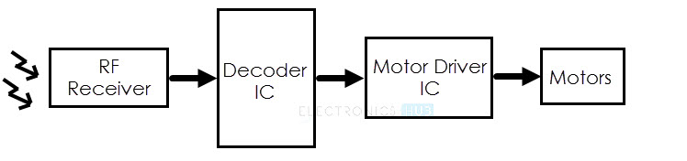

**Fig 5.2**

*Ref-Electrohub.com*

**Circuit Diagram of the Transmitter Section**

The following image shows the circuit diagram of the Transmitter part of the Hand Gesture Controlled robot.

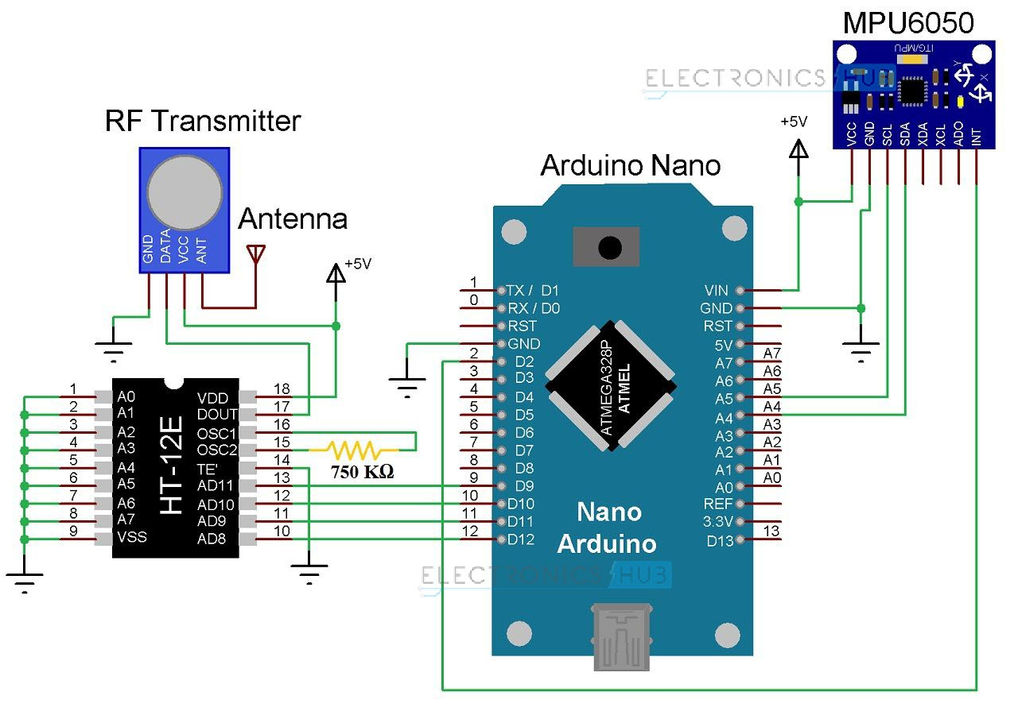

**Fig 5.3**

*Ref-Electrohub.com*

**Components for Transmitter Section**

* Arduino Nano
* OV7670 Camera Module
* 434MHz RF Transmitter
* HT-12E Encoder IC
* MPU6050 Accelerometer/Gyroscope Sensor
* 750KΩ Resistor

**Circuit Diagram of the Receiver Section**

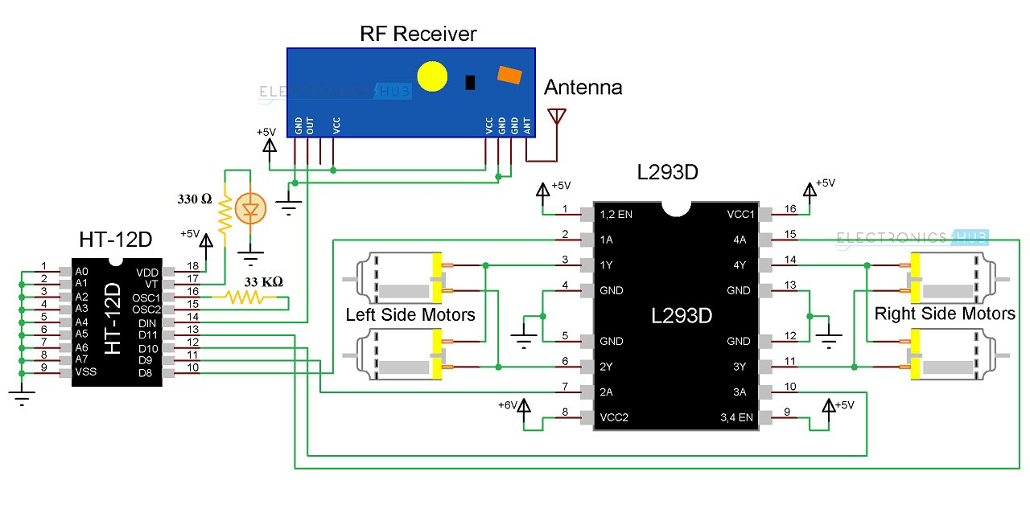

**Fig 5.4**

*Ref-Electrohub.com*

**Components for Receiver Section**

* L293D Motor Driver IC
* HT-12D Decoder IC
* 434 MHz RF Receiver
* 33KΩ Resistor
* 330Ω Resistor
* LED
* 4 Geared Motors with Wheels
* Robot Chassis

**CHAPTER 6**

**CODE**

#include <SPI.h> //SPI library for communicate with the nRF24L01+

#include "Wire.h" //For communicate

#include "I2Cdev.h" //For communicate with MPU6050

#include "MPU6050.h" //The main library of the MPU6050

//Define the object to access and cotrol the Gyro and Accelerometer (We don't use the Gyro data)

MPU6050 mpu;

int16_t ax, ay, az;

int16_t gx, gy, gz;

const int IN1 = 8; //Right Motor (-)

const int IN2 = 9; //Right Motor (+)

const int IN3 = 7; //Left Motor (+)

const int IN4 = 6; //Right Motor (-)

//Define packet for the direction (X axis and Y axis)

int data[2];

void setup(void){

//Define the motor pins as OUTPUT

pinMode(IN1, OUTPUT);

pinMode(IN2, OUTPUT);

pinMode(IN3, OUTPUT);

pinMode(IN4, OUTPUT);

Serial.begin(9600);

Wire.begin();

mpu.initialize(); //Initialize the MPU object

}

void loop(void){

//With this function, the acceleration and gyro values of the axes are taken.

//If you want to control the car axis differently, you can change the axis name in the map command.

mpu.getMotion6(&ax, &ay, &az, &gx, &gy, &gz);

//In two-way control, the X axis (data [0]) of the MPU6050 allows the robot to move forward and backward.

//Y axis (data [0]) allows the robot to right and left turn.

data[0] = map(ax, -17000, 17000, 300, 400 ); //Send X axis data

Serial.println(data[0]);

data[1] = map(ay, -17000, 17000, 100, 200); //Send Y axis data

if(data[0] > 375){

//forward

digitalWrite(IN1, HIGH);

digitalWrite(IN2, LOW);

digitalWrite(IN3, HIGH);

digitalWrite(IN4, LOW);

}

if(data[0] < 330){

//backward

digitalWrite(IN1, LOW);

digitalWrite(IN2, HIGH);

digitalWrite(IN3, LOW);

digitalWrite(IN4, HIGH);

}

if(data[1] > 180){

//left

digitalWrite(IN1, HIGH);

digitalWrite(IN2, LOW);

digitalWrite(IN3, LOW);

digitalWrite(IN4, HIGH);

}

if(data[1] < 110){

//right

digitalWrite(IN1, LOW);

digitalWrite(IN2, HIGH);

digitalWrite(IN3, HIGH);

digitalWrite(IN4, LOW);

}

if(data[0] > 330 && data[0] < 360 && data[1] > 130 && data[1] < 160){

//stop car

digitalWrite(IN1, LOW);

digitalWrite(IN2, LOW);

digitalWrite(IN3, LOW);

digitalWrite(IN4, LOW);

}

}

**CHAPTER 7**

**TEST AND PROCUDURES**

Because of transmitter device wearing on hand and receiver on the robot, the robot starts moving according to the movement of hand gestures. In this paper, we have explained about the 5 different hand gesture or movement positions i.e. stop condition, forward movement, backward movement, moves towards right and moves towards left.

**4.1. Stop Condition**

The robot can be stopped by making the accelerometer parallel to the horizontal plane; this makes all the output pins of decoder (13, 12, 11, 10) set to high.

**4.2 Forward Movement**

The robot starts moving in forward direction, by making accelerometer tilted to forward direction, this condition sets the two output pin of decoder (13, 11) to low and set high on the other two output pin of decoder (12, 10).

**4.3 Backward Movement**

The robot starts moving in forward direction, by making accelerometer tilted to forward direction (upwards), this condition sets the two output pin of decoder (13, 11) to high and set low on the other two output pin of decoder (12, 10).

**4.4 Moves towards Right**

The robot starts move towards right side by tilting the accelerometer towards right, and this makes the two output pin of decoder (12, 11) low and other two output pin of decoder (13, 10) high.

**4.5 Moves towards Left**

The robot starts move towards left side by tilting the accelerometer towards left, and this makes the two output pin of decoder (12, 11) high and other two output pin of decoder (13, 10) low.

**CHAPTER 8**

**FINAL RESULT**

Fig 8.1 Robot Vehicle

Fig 8.2 Hand Gesture Controller

**CHAPTER 9**

**CONCLUSION**

In our project we have added special features by which our robot can overcome so many problems in industry. If it is further developed then it can be used for military application. A Gesture Controlled robot with Arduino Uno microcontroller has been designed in this work, which can be controlled by human hand gestures. This requires to wear a small transmitting device on our hand included an accelerometer, which transmits particular commands to the robot to move according to the users hand gesture and one receiver at the robot.

**9.1 Future Scope**

This project can be enhanced using voice circuit in this for deaf and dumb people. Voice circuit converts gestures into voice. With voice circuit implemented this will be useful for Animal Planet, Discovery people for their studies on animals by playing different sounds & for their exploration. Further we can add GPRS and GPS modules for place location.

**REFERENCES**

[1] Althoff, F., McGlaun, G., Lang, M., Rigoll, G. “Comparing an Innovative 3D and a Standard 2D User Interface for Automotive Infotainment Applications”, Paper. Munich: Technical University of Munich, (2016)

[2] Alpern, M., Minardo, K. “Developing a Car Gesture Interface For Use as a Secondary Task”, Paper PA15213-3891 USA Pittsburgh, USA: Carnegie Mellon University, (n.d.)

[3] Baudel, T., Beaudouin-Lafon, M. “CHARADE: Remote control of Objects using Free-Hand Gestures”, Paper. Paris: Universite de Paris, (2017)

[4] Fels, S. S., Hinton, G. E. “Glove Talk II - a neural network interface which maps gestures to parallel formant speech synthesizer controls”, Neural Networks, IEEE Transactions. 8, Issue: 5, 977-984, (2018)

[5] Harish Kumar Kaura, Vipul Honrao, Sayali Patil, Pravish Shetty, “Gesture Controlled Robot using Image Processing”, International Journal of

Advanced Research in Artificial Intelligence (IJARECE), PP.-69-77, Vol-2, No.-5[2016].

[6] Aditya Purkayastha, Akhil Devi Prasad, Arunav Bora, Akshay kumar Gupta, Pankaj Singh, “Hand Gestures Controlled Robotic Arm”, Journal of International

Academic Research for Multidisciplinary, Vol-2, Issue-4, PP.-234-240, May 2018.

[7] Love Aggarwal, Varnika Gaur, Puneet Verma, “Design and Implementation of Wireless Gesture Controlled Robotic Arm with Vision”, International Journal of Computer Application, Vol-79, No.-13, PP.-39-43, October 2015.

[8] Vicky Somkuwar, Roshan Gabhane, Sandeep kakde, “Design and Implementation of Gesture Controlled Robot using Flex sensor and Accelerometer”.

[9] Gaurav Gautam, Abhijeet Ashish, Anil Kumar, Avdesh, “Wirelessly Hand Glove Operated Robot”, International Journal of Advanced Research in Electronics and Communication Engineering (IJARECE), Volume-3, Issue-11,PP.-1546-1547, November 2014.